**Optimize vCPUs & disabling multi-threading:**

* As we get fixed number of virtual CPUs for an EC2 instance based on it’s type. But we can change it as well.
* Let’s say, t2 large comes with 4 CPUs means it can have maximum upto 4. But we can have less than 4 also.
* This one will be useful when we have an application which license price depends on the no.of cores of the server. Example is informatica.

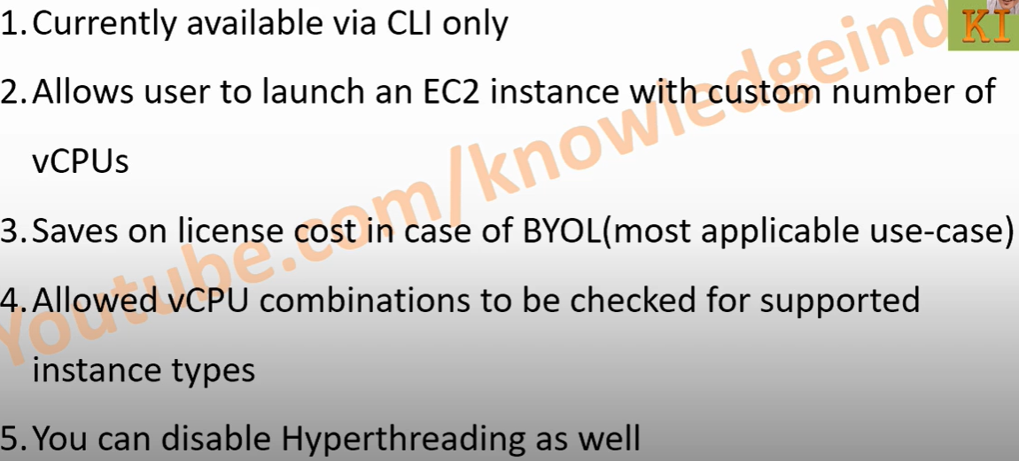

* We can find the details of no.of cores, threads per core & default vCPUs of EC2 instances in aws as per the example below.

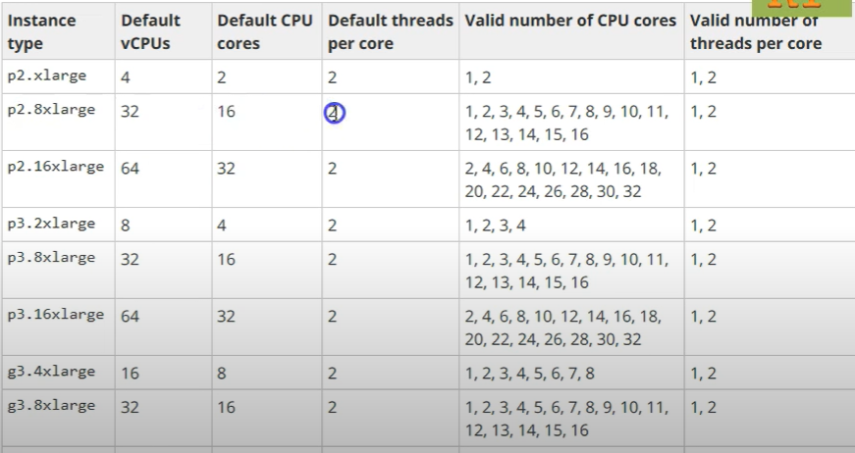

* We can also disable hyperthreading. Giving the no.of threads a 1 means, the vCPUs will come same as the valid no.of cores. Which means the hyper-threading is disabled.

**Specifying the custom no of vCPUs:**

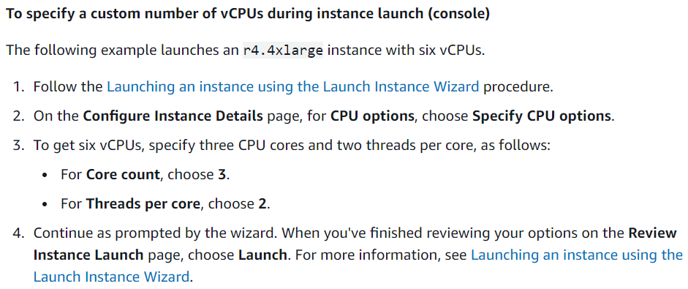

**Disabling multithreading:**

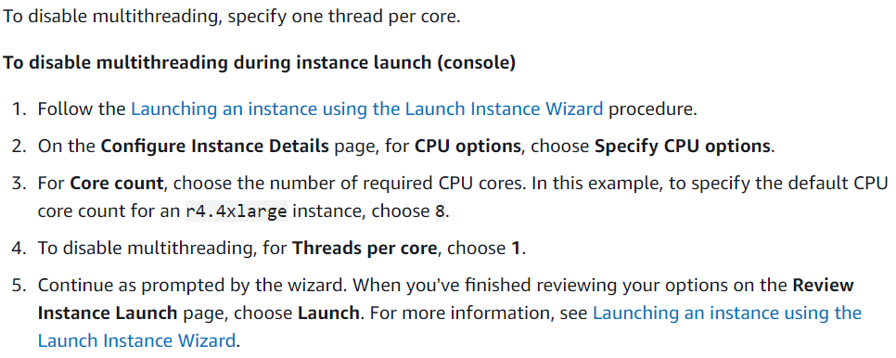

**Viewing the CPU options for your instance:**

